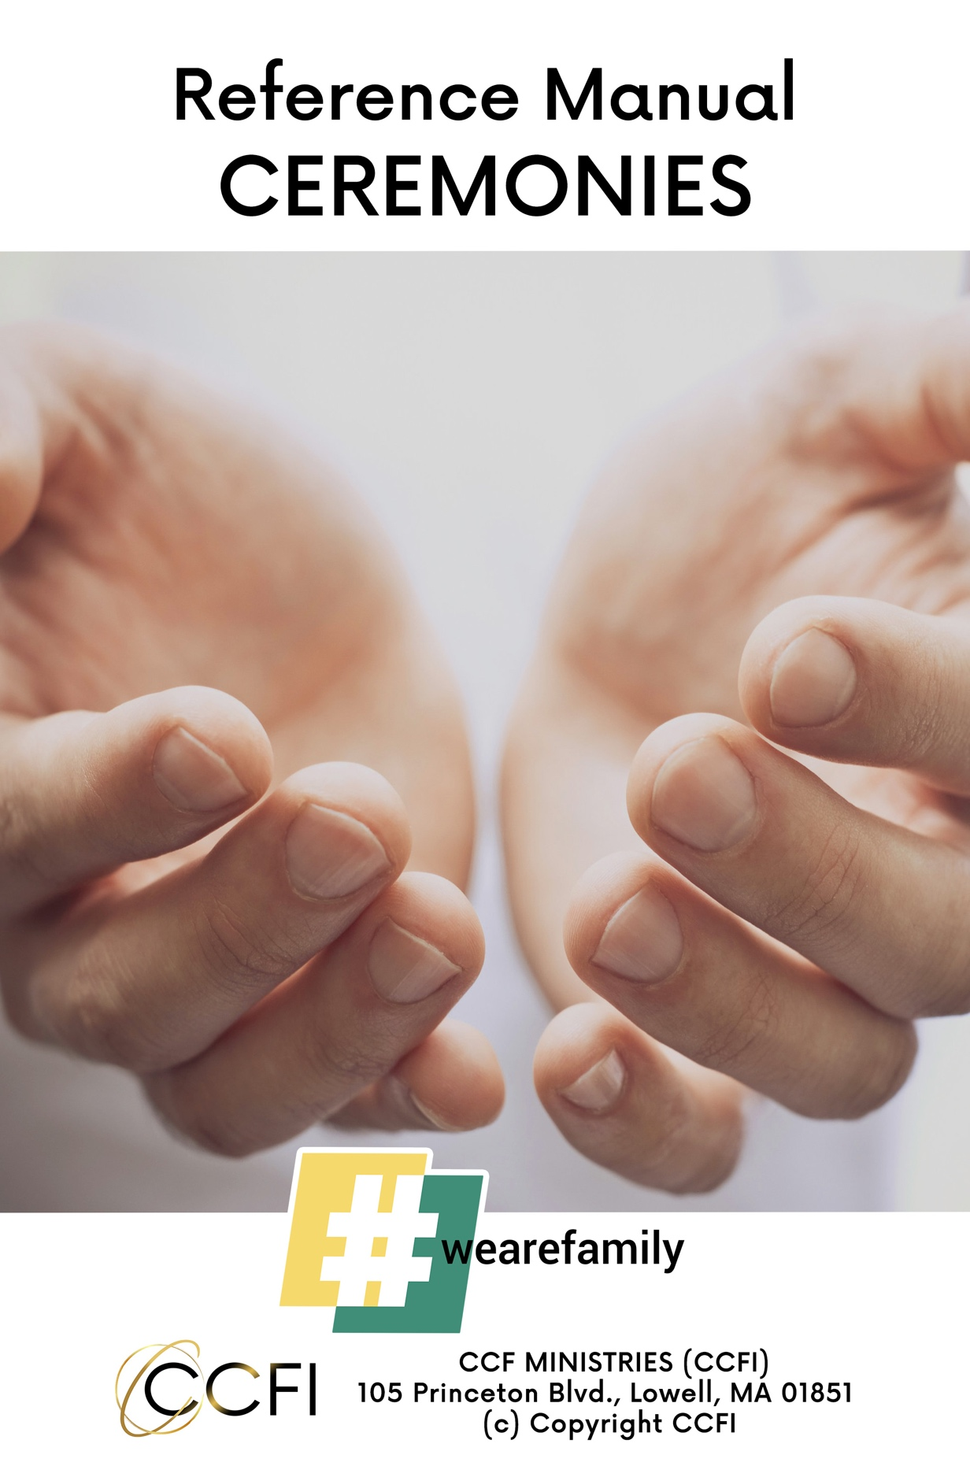

CONTENTS

- Water Baptism
- The Lord’s Supper
- Weddings
- Funerals

Water Baptism

Mark 16:16 : “Whoever believes and is baptized will be saved, but whoever does not believe will be condemned.”

Jesus is teaching us.

- Believing comes before baptism.
- People will not be judged if they are not baptized, only if they do not believe.

CCFI will baptize anyone who confesses Jesus Christ as Lord and Savior.
Children must be at least seven years old. Parents must assure us that the child has committed to Christ and knows precisely what he or she is doing.

Meet with candidates at least two weeks before baptism to explain what baptism is and the procedure.
- Water baptism is a demonstration of our obedience to the Lord Jesus Christ.
- Water baptism is a symbol to identify with the death, burial, and resurrection of Jesus Christ.
- Water baptism is a public declaration of our promise to stop walking in sin.
- Water baptism is an "...appeal to God for a good conscience ..." 1 Peter 3:21
- Tell them what to wear, and to bring dry clothes and a towel.

During the baptism ceremony
- Introduce the candidate to the those in attendance (there should be witnesses)
- Have the candidate share a few words about their commitment to Christ.

CCFI practices the form of immersion:

The Greek word “baptize” means to immerse.
Colossians 2:12 and Romans 6:14 tells us that we are buried with Him in baptism.

It is important for the minister to immerse the candidate fully under the water, declaring,
“Based on your confession before these witnesses that Jesus Christ is your Lord and Savior, we now baptize you in the name of the Father, Son, and Holy Spirit.

Someone should pray with the candidate before going into the water and after coming out of the water.

The Lord’s Supper

Do this in remembrance of Me. This is one of the most essential sacraments in church life. Jesus is telling us to remember Him.

Three major names for this event
- Communion
- The Lord’s Supper
- Breaking bread

Three facts about it
- We commemorate (Remembrance)
- We anticipate (His coming back)
- We participate (Communion, fellowship, coming together)

We observe the Lord’s Supper to commemorate a past event, anticipate a future event, and participate in the celebration of life between the two!

No need to take more than ten to fifteen minutes.

Ceremony-The Lord's Supper

- Start with a song as the elements are being distributed.
- Invite the congregation to participate in reverence.
- Read one of these passages: Matthew 26:26-29 or 1 Corinthians 11:23-33. Explain briefly.
- Invite the congregation to examine themselves.
- Read together out loud Psalm 139:23-24, or lead them in a prayer of repentance.
- You may involve more people by asking one or two people to pray over the elements.
- Ask people to participate together, first the bread, then the cup.
- Say these words when they are ready to eat, “The body of Jesus Christ.”
Say these words when they are ready to drink, “The blood of Jesus Christ.”
9. End with a song.

Wedding Ceremony

Meet with the bride and groom at least two weeks before the wedding to discuss their wishes for the ceremony.

Attend rehearsal two or three nights before the wedding.

Make sure to get the marriage license before you perform the ceremony. It is wiser to take it during the rehearsal and leave it in the office. Sign it after the ceremony. Make a copy for church records and mail the original to the city hall.

If you are performing a wedding out of state, you might need a special permit from that state.

Ceremony-Wedding

- Ask, “Who gives this bride to be wed?”
- Declare, “This is the day that the Lord has made, we rejoice and be glad in it.”
- Ask the bride and groom separately if they have received Jesus Christ as their Lord and Savior.
- After they say yes, declare, "This is a Christian wedding and The Father, Son and Holy Ghost are witnessing this covenant along with a host of angels."
- Share a few words about what Christian marriage is as a covenant.
- Declare over them that a supernatural miracle will occur as you share your vows. The Holy Spirit will join your hearts, and you will no longer be separate but one.
- Pray or ask other pastors to pray. This is a good time for any particular song or special reading by family members or friends.
- Exchange vows- this could be traditional, contemporary, or their own.
- Exchange rings- the best man or ring bearer will have them. They will give the ring to you. Lift the ring and pray over it. Ask the groom to place it on her left hand half way, and ask him to repeat these words, “with this ring I thee wed. I give it as a token of my faith that I now release in Jesus Name, this is forever."
(Repeat the same thing with the bride.)
- Let them join hands. The presiding pastor lays hands on theirs and prays a blessing over them. Declare this statement, “and now in the name of the Father, Son, and Holy Spirit, and by the power vested in me by the state of (____), I now pronounce you husband and wife.
- Take a short pause, then tell the groom, “You may now kiss the bride.” Pause again and ask them to face the audience. Present them by saying, “Ladies and gentlemen, it is my honor to present to you for the first time, Mr. and Mrs. (____)."

Funeral

There are many different branches of Christianity, and funeral customs and etiquette vary among them. However, some Christian funeral traditions are common among most denominations.

CCFI is an international movement. Therefore, we respect the family’s beliefs and culture as long as it does not contradict Biblical teachings.

A family meeting should take place before the funeral.

Funerals are an excellent opportunity for a short salvation message but with respect and sensitivity. The best way is to include everyone to pray the prayer of salvation. It is okay to ask, “If you have prayed this prayer for the first time, can you wave at me so I can keep you in my prayers? You can see me after the service if you want to know more. I am more than happy to meet you."

Popular readings during service
Psalm 27
1 Corinthians 15
1 Thessalonians 4:13-18
Isaiah 57:1-2

Christian Burials and Post-Funeral Practices

Every religion has traditions around cremations and burials. Christian denominations are no different. Christian beliefs about death inform their stances on burial rituals and other practices.

Cremation and burial customs
In a Christian burial, the body of the deceased person is typically interred in consecrated ground. Cremation used to be forbidden in the Christian faith, as it would interfere with resurrection. Over time, those rules have been relaxed.
CCFI believes that resurrection power is not limited. Just as there were many Christians burned as martyrs, or died in plane accidents, or at sea, God can and will raise us all, whether we are in the ground or in an urn.
In Catholic tradition, cremated remains are still buried. Other Christian sects allow for ashes not to be interred, while some have strict rules against scattering them. CCFI will leave it up to the family to choose.
American funeral services usually last no longer than forty-five minutes. Other cultures may take longer. Respect the culture that is having the ceremony.
Christian funerals can take place in a church, at the funeral home, or simply at the cemetery, depending on the family's wishes.

While the exact order and features of the service vary depending on the denomination, culture, or wishes of the deceased, a Christian service generally includes the following elements:

Casket: The body of the person who has passed away is present at the ceremony in a casket. If the person has been cremated, the urn is present instead. The casket or urn is either carried into the church or other building at the start of the ceremony or placed in a prominent location before the ceremony begins.
Opening statement: The pastor delivers an opening statement to welcome attendees, offers words of support for the family, and leads an initial prayer to start the ceremony.
Prayers and hymns: Other clergy or family members may lead a range of prayers and hymns throughout the ceremony. The congregation is often encouraged to sing along. Songs should be short, sweet, respectable, and fitting.
Ex: Amazing Grace, How Great Thou Art, What a Friend We Have in Jesus, It is Well With My Soul
Readings and speeches: Friends and family may share readings and speeches during the ceremony. For example, they might read a eulogy or say a few words about the person who has passed away.
Short Sermon:
Closing words: The pastor shares a short benediction, offering comfort for the bereaved or reminding them of the importance of living a faithful Christian life and serving God.
Burial: Often, a burial or cremation ceremony follows on the same day as the funeral service. The pastor says a few words at the burial as people gather at the site.
Fitting scripture readings:
Psalm 23
Ecclesiastes 3:1-4
John 14:1-3

Give time for the family to say their last goodbyes according to their culture.



