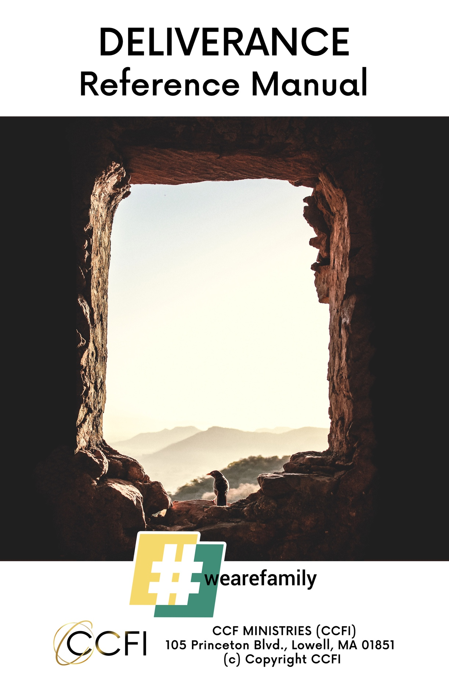

**Definitions:**

***Deliverance*** means “liberation, freeing, rescuing, or restoring.”

***To restore*** means, “to repair, renovate, or return to a former condition.”

***Psalm 23:3****, “He restores my soul.”*

***Psychology*** is the science of the soul. Psychology comes from the Greek word *psyche,* which means “soul” and *logos,* which means “to study.”

The word ***salvation*** in Greek is *soteria* derived from the root word *sozo*. *Sozo* is a Greek word that means “wholeness.”

It refers to the complete healing for the body, soul and spirit (mind, will, and emotions).

**Deliverance Ministry:**

In Christianity, the deliverance ministry refers to individuals or groups that, through the power of the Holy Spirit, perform practices and rituals to cleanse people of demons and evil spirits.

**What is deliverance:**

Deliverance refers to setting people free from demonic evil spirits that are causing problems for them.

**Two extreme and unrealistic beliefs:**

1. There are no demons.
2. There is a demon behind every problem.

**The difference between demon possession and demonic oppression:**

To be possessed is to be fully under the control of the demon (ownership), while to be oppressed means to be under demonic power or influence in certain areas.

**Why is deliverance necessary:**

* To liberate the church
* To Unleash God’s power in and through believers
* To prepare the Bride of Christ for the imminent return of the Lord

***Acts 5:16:*** *“There came also a multitude out of the cities round about unto Jerusalem, bringing sick folks, and them which were vexed with unclean spirits: and they were healed everyone.”*

***Acts 8:6-7:*** *“And the people with one accord gave heed unto those things which Philip spoke, hearing and seeing the miracles which he did.  For unclean spirits, crying with loud voice, came out of many that were possessed with them: and many who were paralyzed and lame were healed.”*

**Important facts about the deliverance ministry:**

* We do not look for demons. We look to free people from bondage.  The focus is not on demons; it is about loving people and helping them live free of evil forces.
* The essence of the deliverance ministry is to seek the root cause, or right access; a pathway that the person has opened up that has allowed the demon to afflict them.

***John 14:30:*** *“I will no longer talk much with you, for the ruler of this world is coming, and he has nothing in Me.”*

**Why are people demonized:**

* Lack of adherence to the word of God.

***Matthew 4:3-4:****“Now when the tempter came to Him, he said, ‘If you are the Son of God, command that these stones become bread.’ But he answered and said, ‘It is written, man shall not live by bread alone, but by every word that proceeds out of the mouth of God.’”*

* Not living a life of total surrender to God

**The devil’s strategy:**

* To gain the legal right to attack us as we knowingly or unknowingly open the door just enough to allow him entrance into our lives.
* According to George Otis, Jr., there are three kinds of people:

1. Prisoners- those whom Satan has already captured
2. Targets- those whom Satan is actively attempting to entrap
3. Adversaries- those who are actively opposing him

The access is almost always through sin.  The devil’s strategy is incremental:

1. He first seeks to gain a foothold through our fleshly desires.

***Romans 7:8*** *“But sin, taking opportunity by the commandment, produced in me all manner of evil desire.  For apart from the law sin was dead.”*

***James 1:14:*** *“But every man is tempted, when he is drawn away of his own lust, and enticed.”*

1. He then seeks to expand the foothold as he continues to exploit our areas of weakness.

***Ephesians 4:27:*** *“Neither give place to the devil.”*

1. If these initial attempts are successful, then he will seek to develop a stronghold, which is simply a way of thinking in our minds that is contrary to God’s way of thinking.

***1 Corinthians******10:4-5****: “And all drank the same spiritual drink. For they drank of that spiritual Rock that followed them, and that Rock was Christ. But with many of them God was not well pleased: for their bodies were scattered in the wilderness.”*

***1 Corinthians 2:11****: “For what man knows the things of a man, except the spirit of the man which is in him? Even so no one knows the things of God except the Spirit of God.”*

**Overview of Deliverance Ministry**:

* The key to the actual process of deliverance is recognizing the authority of the Lord Jesus Christ.
* In the New Testament, three of the six words translated from the Greek for the word “power” are:
* *Dunamis, “*the ability, power, miraculous power, that which manifests God’s power, power or ability residing in a person or thing; power in action, force”
* *Exousia*, “authority, freedom of action, the right to act”
* *Kratos*, “strength”
* Satan receives “kratos” (strength) through “exousia” (authority)

***Hebrews 2:14:*** *Forasmuch then as the children have partaken of flesh and blood, He himself likewise share in the same, that through death He might destroy him who had the power of death, that is, the devil;*

* He only has the authority to act in our lives if it is given to him by us. If we don’t give him the authority *(exousia),* he doesn’t have the strength *(kratos)!*
* Our understanding of the issue of authority is absolutely crucial in order to be effective in deliverance ministry.
* It is only through the power of the Holy Spirit that we have authority over the powers of darkness.

**Jesus is the Deliverer:**

***1 John 3:8: “****He who sins is of the devil, for the devil has sinned from the beginning. For this purpose, the Son of God was manifested, that He might destroy the works of the devil.”*

***Mark 1:23-26:*** *“Now there was a man in their synagogue with an unclean spirit. And he cried out, saying, ‘Let us alone! What have we to do with You, Jesus of Nazareth? Did You come to destroy us? I know who You are—the Holy One of God!’ But Jesus rebuked him, saying, ‘Be quiet, and come out of him!’ And when the unclean spirit had convulsed him and cried out with a loud voice, he came out of him.”*

***Mark 16:15-18: “****And He said to them, ‘Go into all the world and preach the gospel to every creature. He who believes and is baptized will be saved; but he who does not believe will be condemned. And these signs will follow those who believe: In My name they will cast out demons; they will speak with new tongues; they will take up serpents; and if they drink anything deadly, it will by no means hurt them; they will lay hands on the sick, and they will recover.’ ”*

**Order of Ministry:**

(Professed by individual seeking deliverance)

* Begin with prayer.
* Break the power of each strongman:

1. Bitterness

2. Accusing spirits

3. Trauma

4. Envy/Jealousy

5. Rejection

6. Unloving spirits

7. Fear

8. Occultism

* Deal with each of the underlings:

1. Unforgiveness

2. Resentment

3. Retaliation

4. Anger/Wrath

5. Hate

6. Violence

7. Murder

* Then go back and cast out the strongman.
* If necessary, speak a creative miracle into being.

**Example:**

Father God- I take responsibility for ____ in my generation and all previous generations on both my mother’s and my father’s side all the way back to Adam.  I repent of and renounce the spirit of _______.  I ask forgiveness for allowing ____ in my life and cooperating with it.  I ask now that the curse be broken.

In the Name of Jesus of Nazareth, by the power of the Holy Spirit, I take authority over you, spirit of ____. I break your power spirit of ____ and cancel your assignment.  I cast you out spirit of ____ and consign you to the dry places.  Father God, heal the place where ____ has been and fill that place with Yourself.

**Ministering to Personal Trauma:**

* Begin with prayer, seeking His guidance.  On a sheet of paper, write down every trauma you can remember.  List your reactions to these incidences.  For example:fear, anger, hatred, feelings of abandonment, guilt, etc.  These are the spirits that entered through the door of trauma.
* Next, use the trauma prayer template to remove the effects of that trauma from your life.

**Example**

In the Name of Jesus Christ of Nazareth I break off the trauma of ________. I close that door now.  Father God, heal the place where the trauma of _____ has been and fill it with Yourself.

WWW.CCFINTERNATIONAL.ORG

ccfioffice@gmail.com

Ver. 2, 5/4/23